# Result Comparison

Using the fact that there were two projects which simulate atmospheric effects viewed from space, the result obtain from them was compared, and although the effects are very similar there where some differences. When positioning the camera to obtain (inserir referencia da 1º figura aqui) it was noticed some red/yellow shades on Earth’s edge, slightly visible on this figure. Regardless, the effect obtained was very similar, as shown on (inserir referencia da 1º figura aqui).

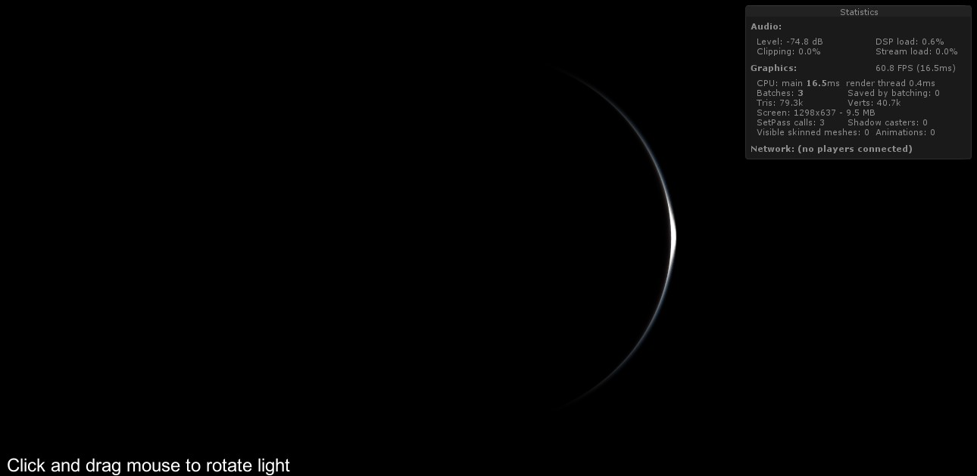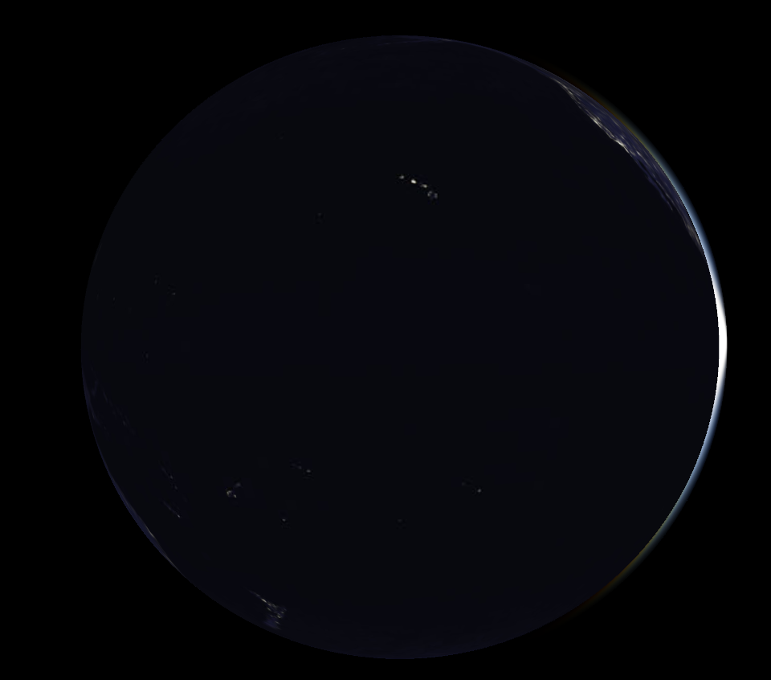

It is believed that the small differences are owing to the diverse way that lights are defined, since minuscule variations in the light’s position or direction on the Nau3D XML file would change the simulated result by a great deal.

When changing the camera position to obtain (inserir referencia da 2º figura aqui) some dissimilarities are also observable, mainly on earth, where the shader being used on Nau3D does not implement atmospheric effects, consequently Unity 3D’s result is more realistic.

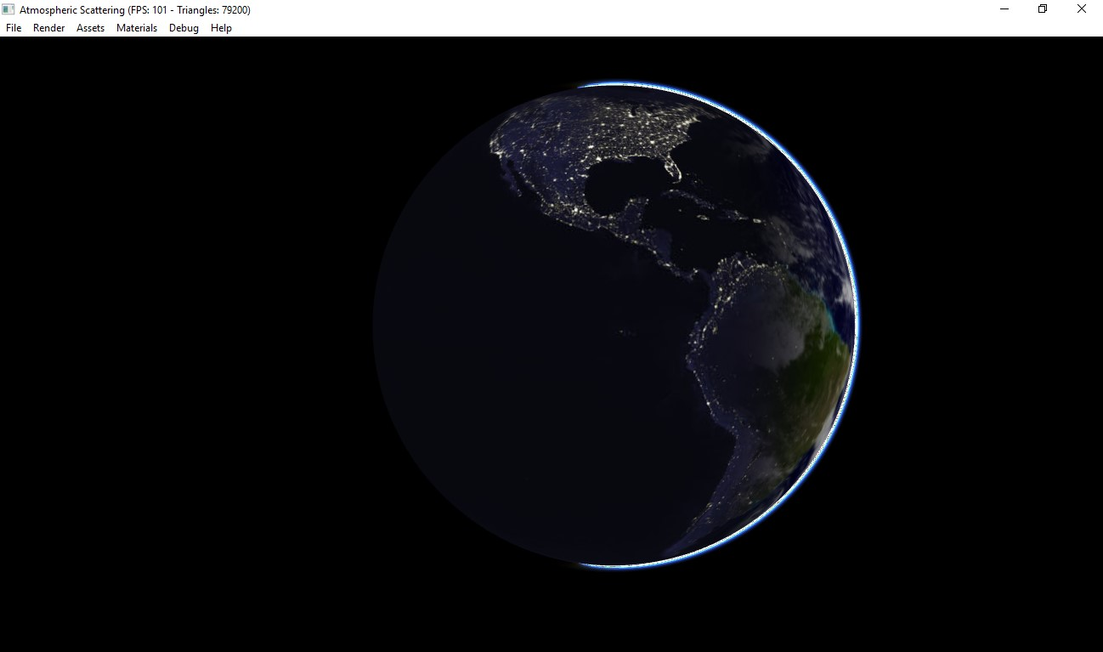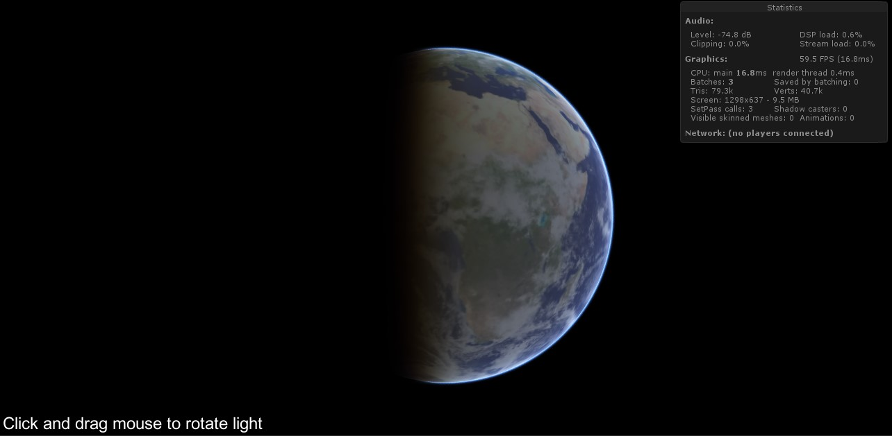

# Annex – Sunrise in Unity 3D

As mentioned before, on this work assignment it was not possible to translate the Unity 3D shader where the point of view was the Earth’s surface in order to use them on the Nau3D engine. Even so the preexistent project was used to simulate the atmospheric effects that can be seen every day, such as the sunrise, sunset, general color of the sky, and so on… (inserir referencia de figura aqui) represents three sunrise stages from Unity 3D recreation, where the sky’s colors variation is explicit, and .varying with the sun’s position.

